Must be returned no later than April 30th, 2024.

Scholarship Awards of $1,000 each will be given to eight (8) of our high school graduates enrolled in any accredited four-year college or university by the Artisans Dining Club, bringing the total first year scholarship money awarded to $8,000.

THE FOLLOWING RULES APPLY

- Must be a high school senior who has been a Junior or Senior of the Artisans for at least two years preceding the date of application for the scholarship.

- Applications shall be made on official forms available at the main office and must be returned to the main office before April 30th, 2024.

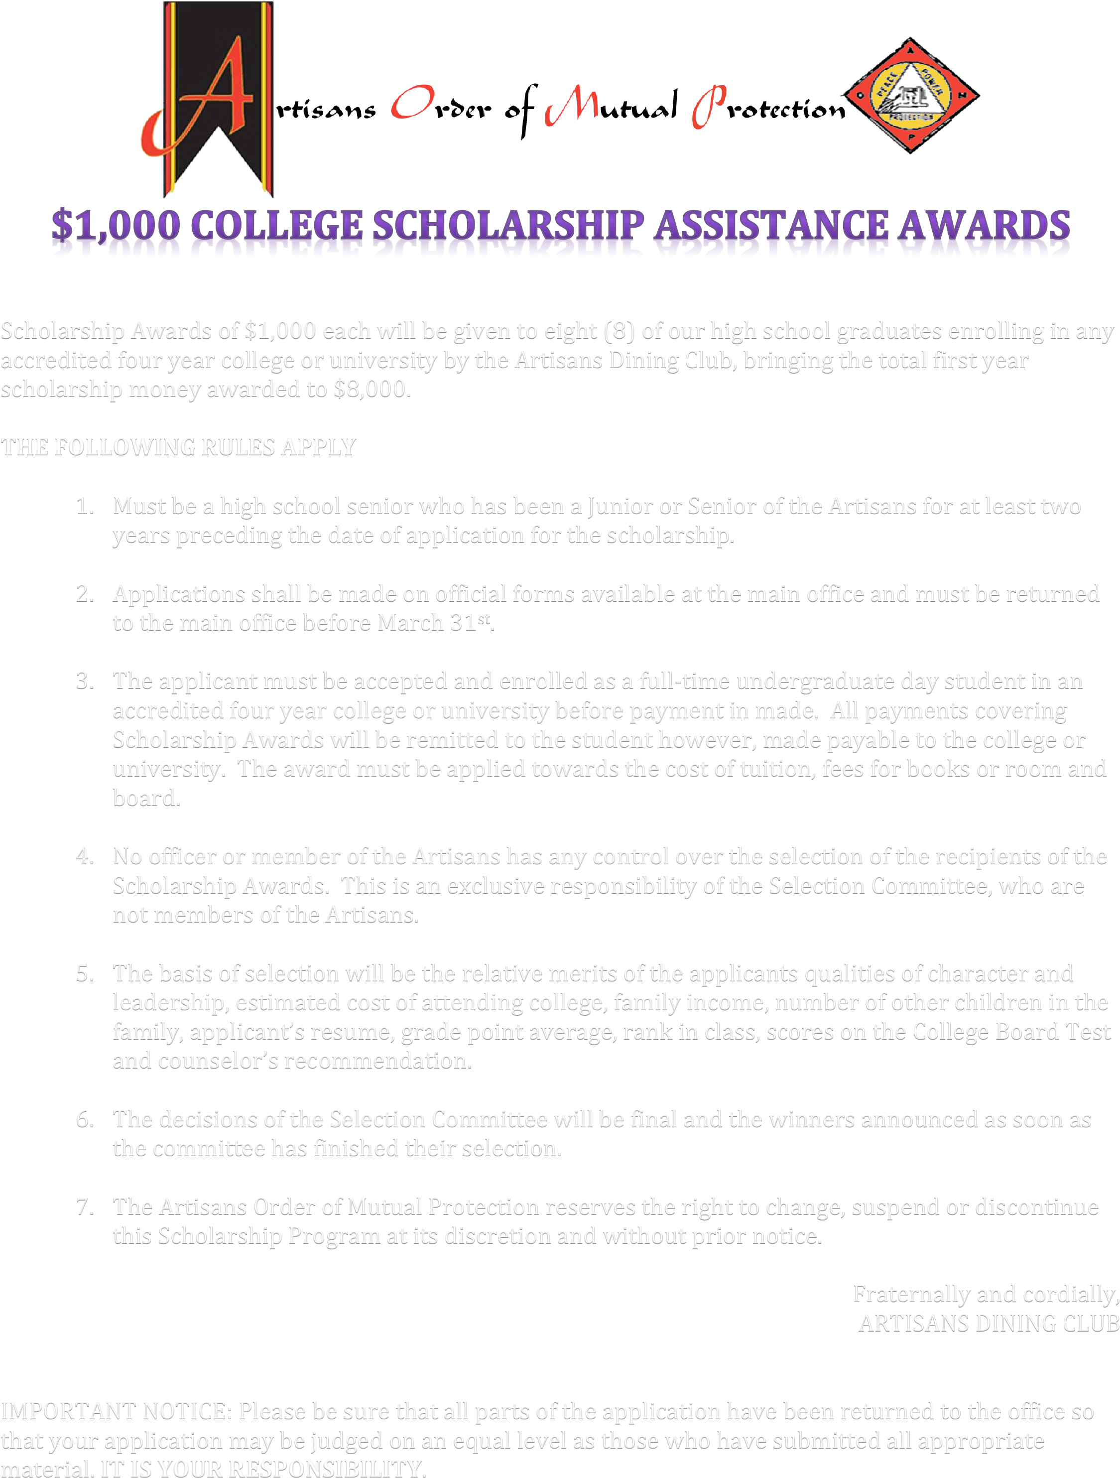
- The applicant must be accepted and enrolled as a full-time undergraduate day student in an accredited four-year college or University before payment is made. All payments covering Scholarship Awards will be remitted to the student however, made payable to the college or University. The award must be applied towards the cost of tuition, fees for books or room and board.

- No officer or member of the Artisans has any control over the selection of the recipients of the Scholarship Awards. This is the exclusive responsibility of the Selection Committee, who are not members of the Artisans.

- The basis of selection will be the relative merits of the applicants’ qualities of character and estimated cost of attending college, family income, number of other children in the family, applicant’s resume, grade point average, rank in class, scores on the College Board Test and counselor’s recommendation.

- The decisions of the Selection Committee will be final, and the winners will be announced as soon as the committee has finished their selection.

- The Artisans Order of Mutual Protection reserves the right to change, suspend or discontinue this Scholarship Program at its discretion and without prior notice.

Fraternally and cordially,

ARTISANS DINING CLUB

IMPORTANT NOTICE: Please be sure that all parts of the application have been returned to the office so that your application may be judged on an equal level as those who have submitted all appropriate material. IT IS YOUR RESPONSIBILITY.

